Cryptocurrencies and Zero Mode Wave guides: An unclouded path to a more contiguous Cannabis sativa L. genome assembly.
Kevin J. McKernan¹, Yvonne Helbert¹, Liam T. Kane¹, Heather Ebling¹, Lei Zhang¹, Biao Liu¹, Zachary Eaton¹, Luo Sun³, Eileen Dimalanta³, William Barbazuk²,Timothy Harkins

1.Medicinal Genomics, 8 Cabot Road, Woburn MA 01801
2. Department of Biology and the Florida Genetics Institute, University of Florida, Gainesville, Florida 32611
3.New England Biolabs, 240 Country Club Road, Ipswich MA, 01938

We describe the use of a Decentralized Autonomous Organization (DAO) to crypto-fund the single molecule sequencing and publication of a Type II Cannabis plant. This resulted in the construction of the most contiguous Cannabis genome assembly to date. The combined use of the Dash cryptocurrency, DAOs, and Pacific Biosciences sequencing delivered a 1.03 Gb genome with a N50 of 665Kb in 77 days from funding to public upload. This represents a 300 fold improvement in the contiguity of the first cannabis assemblies in 2011 and a 4 fold improvement over all cannabis assemblies to date. HiC data from Phase Genomics further improved the assembly to 894 contigs at an N50 of 5.4Mb. The genome is partially phased and 30% larger than previously reported. The CBCA, THCA and CBDA synthase gene clusters have been phased onto respective contigs demonstrating tandem repeat expansions.

Introduction
“A lie can spread half way around the world before the truth puts its boots on”. This quote is often attributed to Mark Twain and ironically was never authored by him. Since the days of Socrates and Galileo, people have been persecuted for their pursuit of the truth. Much of the unwarranted persecution of intellectual inquiry has been attributed to hierarchical social organizations. These organizations have fought to influence and conflate social or religious consensus, with scientific truth. As an example, Gutenbergs’ disruptive printing press was restricted and became a catalyst for the Protestant revolution¹. While hierarchies are believed to be emergent in many biological systems, their development is often associated with the cost to establish neural network connections². Censorship resistant, Peer to Peer networks delivered by cryptocurrencies alter these dynamics.

Restriction of free speech and intellectual inquiry is still alive today in the form of centralized hierarchical social media outlets and the surveillance and censorship these centralized databases create. Today, various social media outlets ban Cannabis related content and have even published manuscripts titled “Experimental evidence of massive-scale emotional contagion through social networks”. This work describes psychological experiments designed to polarize people. These experiments were performed on 689,003 people on Facebook and resulted in distrust of the voting systems with their extension to Cambridge Analytica.

Prior to social media, similar yellow journalism and scientific suppression has occurred in the field of cannabinoid sciences. This distortion has persisted in the United States since 1937 despite an explosive internet and telecommunications revolution. Much of this telecommunication expansion relied on a centralized network topology with fewer checks and balances or incentive structures designed to resist regulatory capture⁵ ⁶. Blockchain technology emerged to fill this void. The distributed ledgers are censorship resistant and offer a new medium for politically liberated and immutable scientific journalism.

We describe the utilization of these new communication platforms to fund the use of zero mode wave guides at the heart of Pacific Biosciences single molecule sequencing platform⁷. These blockchain platforms can also augment traditional publication platforms and strengthen the publication process with unique digital notarization features common to most blockchains. Copyright free and open access publication are facilitated with globally distributed, censorship resistant blockchains. Combined, these tools enabled the creation of the most contiguous Cannabis sativa L. genome reference assembly created to date.

Background on Crypto Currency
In 2008, Nakamoto et al. described a method of maintaining a globally distributed immutable public ledger⁸. The described blockchain technology and its immutable ledger immediately became the internet of money⁹. Bitcoin and derivatives like Dash enabled the construction of trust on the internet through globally recorded proofs of communication with public-private key cryptography. With this architecture many experiments in blockchain governance were hatched. The Bitcoin open source code base has led to mostly volunteer code support. This exposes the network to the possibility of outside adverse entities (potentially threatened by Bitcoin) to covertly fund its evolution in their preferred direction. Much like modern purchasable politics or regulatory capture, this has become a proposed attack surface for Bitcoin¹⁰.

The cryptocurrency Dash forked off of Bitcoin in 2014 seeking faster upgrade cycles that were more focused on fungibility, retail settlement time and scalability. Many alternative cryptocurrencies forked off of Bitcoin or boot strapped their own blockchains towards similar ends. Coinmarketcap.com displays the transaction volumes and price of many of these cryptocurrencies.

One of Dashs’ unique fork attributes was the construction of a blockchain voting and governance model that directed the use of blockchain minted treasury funds. In the case of Bitcoin, 100% of the block rewards are distributed to the miners securing the network with Exahashes/sec of ASIC powered computation. This monetary reward in 2018 is 12.5 Bitcoin approximately every 10 minutes or over $10.8M per day at $6,000 per Bitcoin. This monetary reward has attracted the largest globally distributed super computer network to participate in this security protocol. This immutable Bitcoin ledger can be helpful for securing high value transactions but has been critiqued as being energy intensive, superfluous and even counterproductive for retail micro-transactions.

To accomplish blockchain governance, Dash forked a code base with a different monetary reward policy that was a hybrid of Proof of Work (PoW) and Proof of Stake (PoS). With each 2.5 minute block cycle, Dash would distribute monetary inflation differently than Bitcoin. As opposed to the Bitcoin policy of 100% of the block rewards being distributed to miners (computers securing the a blockchain), 45% of Dash rewards are awarded to miners, 45% awarded to masternodes (MNO) for hosting services and 10% minted to fund a treasury administered by the masternode community. Masternodes function like a large board of directors. Masternodes also have to maintain a full copy of the blockchain, and demonstrate via digital signature a Proof of Stake (PoS) of at least 1000 Dash. This PoS also came with a Proof of Service. To maintain block rewards, masternodes must also maintain servers capable of fast block propagation throughout the peer to peer network that can facilitate 1-2 second transaction speeds.

As a comparison, Bitcoin achieves an on-chain transaction rate of 3-4 transactions per second but with a 10 minute confirmation pulse. Visa and Paypal rely on networks capable of 200-2,000 transactions per second but suffer from an annual $20B-$190B in fraud¹³. Historically, this was considered an unavoidable tradeoff between speed and security. The novel cryptographic techniques used by Dash and other cryptocurrencies challenge these assumptions. The security versus scalability attributes may not be a mutually exclusive trade-off with all cryptocurrency architectures and this remains an important debate in the cryptocurrency field¹⁴⁻¹⁶.

Many in the Dash community believed a cryptocurrency without liquidity and fungibility could never maintain itself as a store of value. As described by Mises, the store of value in a currency is dependent on its liquidity. Thus any software feature producing a lack of liquidity can be a monetary Achilles heel of a cryptocurrency¹⁷. Bitcoin exhibited a lack of liquidity in late 2017 with transaction fees rising to $50 per transaction. This is being addressed in 2018 with the launch of a second layer, off-chain Lightening network.

Two issues are paramount to maintaining currency liquidity. First is the ability to evolve, often reflected in the governance mechanism of the cryptocurrency. Second is the ability to scale to handle a sufficient number of transactions per second to support a substantial economy. Bitcoin’s governance model is overwhelmingly weighted to resist change rather than encourage and facilitate innovation. Ossified community governance seen in the Bitcoin block size debate in 2017 lasted nearly 2 years and cost substantial loss in Bitcoin cryptocurrency maketshare. The Dash DAO anticipated this resistance and forked off in 2015. The blockchain based voting governance designed into DASH demonstrated its agility in 2016. Dash solved its block size debate in a 24 hour vote compared to the multi-year heated debate seen with the August 1, 2017 Bitcoin and Bitcoin Cash forks.

The two layer Dash architecture is believed to be a more scalable point of sale design as the masternode networks’ staked coins can be used as fast digital escrow to enable urgent sub block cycle transactions. These “instant send” transactions can be guaranteed in two seconds or less. Most cryptocurrencies lack this feature and can take 2-10 minutes to lock a transaction. This feature enables a cryptocurrency to compete for store front transaction settlement in Cannabis dispensaries where the average purchase of $72 can not wait for Bitcoins’ 10 minute settlement time, nor risk an unconfirmed Bitcoin transaction often suggested for $1-$5 coffee¹⁸. Unconfirmed transactions are vulnerable to a double spend attack and are less desirable for store front merchants.

This Dash fork gave birth to the first Distributed Autonomous Organization (DAO). There are over 4833 Dash masternodes (MNOs) that are globally distributed and can vote on the algorithmically controlled use of monetary expansion of the currency. The Dash whitepaper describes incentives and randomization of these masternodes that dis-incentivize these masternodes from all being owned by one entity¹¹.

The Dash DAO represents a borderless and voluntary digital democracy that can offer an alternative funding model for socially important scientific projects that threaten the existing oligarchical control structures in the incumbent markets that new scientific findings may influence¹⁹. As an example, there are pharmaceutical companies (Insys) that have been convicted of bribing physicians to prescribe more opiates (Subsys) while simultaneously attempting to get cannabinoids approved with the FDA. This same pharmaceutical company spent over $500,000 lobbying to keep cannabis illegal in the state of Arizona despite extensive evidence that legal cannabis states witness reduced opiate consumption²⁰.

Sequencing politically restricted yet democratically popular genomes presents unique challenges. Political will is often first manifested through sanctions, tariffs, currency control and financial regulation. For this reason funding cannabinoid research in many jurisdictions has been met with decades of friction despite FDA approved evidence for cannabinoid therapy in life threatening epilepsy and cancer pain or nausea²¹⁻³⁶. Global cryptocurrencies and novel governance models manifested in DAOs present a novel mechanism for funding pressing scientific issues that remain politically but unjustly persecuted.

Immutability and tamper evident scientific data
Cryptocurrencies are globally distributed ledgers and represent the fastest growing global currencies for the last decade. These tools have the power to enable funding to any jurisdiction in the world with mobile internet access and represent a unique monetary tool for efficient global charity and the democratization of scientific pursuit. They are also extremely censorship resistant.

The value of any given network is often assessed as a geometric function of the number of network participants. There are an estimated 2 billion people that are unbanked and half of them have mobile phones³⁷. Cryptocurrencies and distributed ledgers promise financial and scientific inclusion to the unbanked world. New international partnerships and entrepreneurship can be enabled with these global trust networks.

These immutable ledgers also offer a unique publication platform for digital notarization and tamper evidence of scientific data. Hashes of key experimental data can be embedded in Bitcoin or Dash transactions and the owner of said data can prove authorship with public-private key cryptography securing the transaction. The alteration of a single bit of information in that data will generate a completely different hash signifying a change. These tamper resistant data structures are time-stamped into highly secure and immutable blockchains. This is often referred to as “hashing and stashing” data, “proof of existence” operation or POE.

This POE operation makes use of the Bitcoin OP_RETURN function. It is a unique field in Bitcoin and Dash transactions that allows metadata to be embedded within the transaction. The most well known meta data embedded in a block was left by Nakamoto et al. in the coinbase of the genesis block of Bitcoin stating “The Times 03/Jan/2009 Chancellor on brink of second bailout for banks”. Bank bailouts have become politically popular but democratically unpopular redistributions of wealth that Bitcoin was specifically designed to counter.

Dash is a fork of Bitcoin designed to have more democratic governance. The Dash treasury distributes over 6,176.72 Dash every 16,616 blocks or roughly 28.8 days. When Dash soared to over $1400 per coin in late 2017, this treasury was a generous $8.6M/month entrepreneurial pool. This created a monthly grant distribution mechanism for various projects that expand the impact of Dash.

The awarded Dash proposals have included hurricane and earthquake relief charities, journalistic freedom sponsorships, merchant adoption projects and many others. In 2018, Dash began to fund certain scientific endeavors that promise to expand cryptocurrencies into large markets with high banking friction.

Medicinal Genomics submitted a Dash proposal for sequencing the Cannabis genome to the fullest extent possible as the foundation for a blockchain based Cannabis seed to sale tracking system. Medicinal Genomics sequenced the Cannabis sativa genome in 2011 with Illumina sequencing technology. Due to the complexity of the Cannabis genome, this first attempt resulted in a very fragmented draft genome of limited utility. 7 years later single molecule sequencers were demonstrating high quality 50,000 base pair reads. A few promising cannabis assemblies on the Pacific Biosciences RSII platform delivered N50s of 159kb (https://www.ncbi.nlm.nih.gov/nuccore/MNPR00000000.1/). It was hypothesized that the newer Pacific Biosciences Sequel chemistry could bring the genome over the N50 500kb threshold used to celebrate the Human Genome at the White House in 2001³⁸.

Dash Proposal Process
The Dash treasury witnessed a tripling of proposals submitted per month in 2018 making it a very competitive process. To limit spam, each proposal has to spend 5 Dash as an application fee. This fee is designed to create a monetary incentive to keep proposal owners from submitting low quality proposals. Fees are non refundable for failed proposals but can be included into successful proposals budgets.

The original cannabis genome proposal was rejected in March and April but refined and eventually voted in on May 30th, 2018 for 30 Dash/month for 5 months. The votes are never final. Any month during the duration of the project votes can be pulled or provided and defunding can occur if the project appears to be missing milestones. This feature is notably absent in many traditional funding sources or democratic political systems. Votes are all recorded on the blockchain and can be monitored at various websites seen below.
- https://dashnexus.org/leaderboard
- https://www.dashninja.pl
- https://www.dashcentral.org
- https://dashwatch.org/cards/

The treasury also funds various auditing bodies like Dash Watch. These auditing bodies organize monthly reports for each proposal and attempt to identify failing projects or scams for the masternode network.

Cryptocurrency methods
Once the proposal received a successful vote on May 30th, 2018, a 30 Dash per month payment cycle was initiated directly by the blockchain on June 3rd, 2018 directing funds to a Medicinal Genomics provided Dash address. In the event of a successful vote, each proposal must be submitted with a Dash address. A Dash QT client is required to initiate the contract for the project proposal. The contract utilizes multi-signature and time lock verify features of Bitcoin and Dash where multiple signatories are required to initiate a time locked contract. Once the masternodes vote on the project before the superblock deadline, the Dash is sent to addresses listed in the rudimentary “smart” contract.

The private key for this project resided on a hardware wallet (often referred to as a cold wallet) from Trezor.io. Cold wallets are imperative for projects with public and predictable cryptocurrency transactions as these types of transactions draw the attention of hackers and can result in theft. Cold wallets are highly recommended. If theft occurs, there is no governing body that can retrieve your coins. Cold wallets or hardware wallets reside on devices that can be physically unplugged from the internet and offer higher security than wallets residing on phones or internet linked laptops. Many hardware wallets provide anti-keyboard sniffing authentication interfaces. While not used for this project, the use of virtual private networks (VPN) and The Onion Router (tor) browser can further aid in security of larger cryptocurrency transactions.
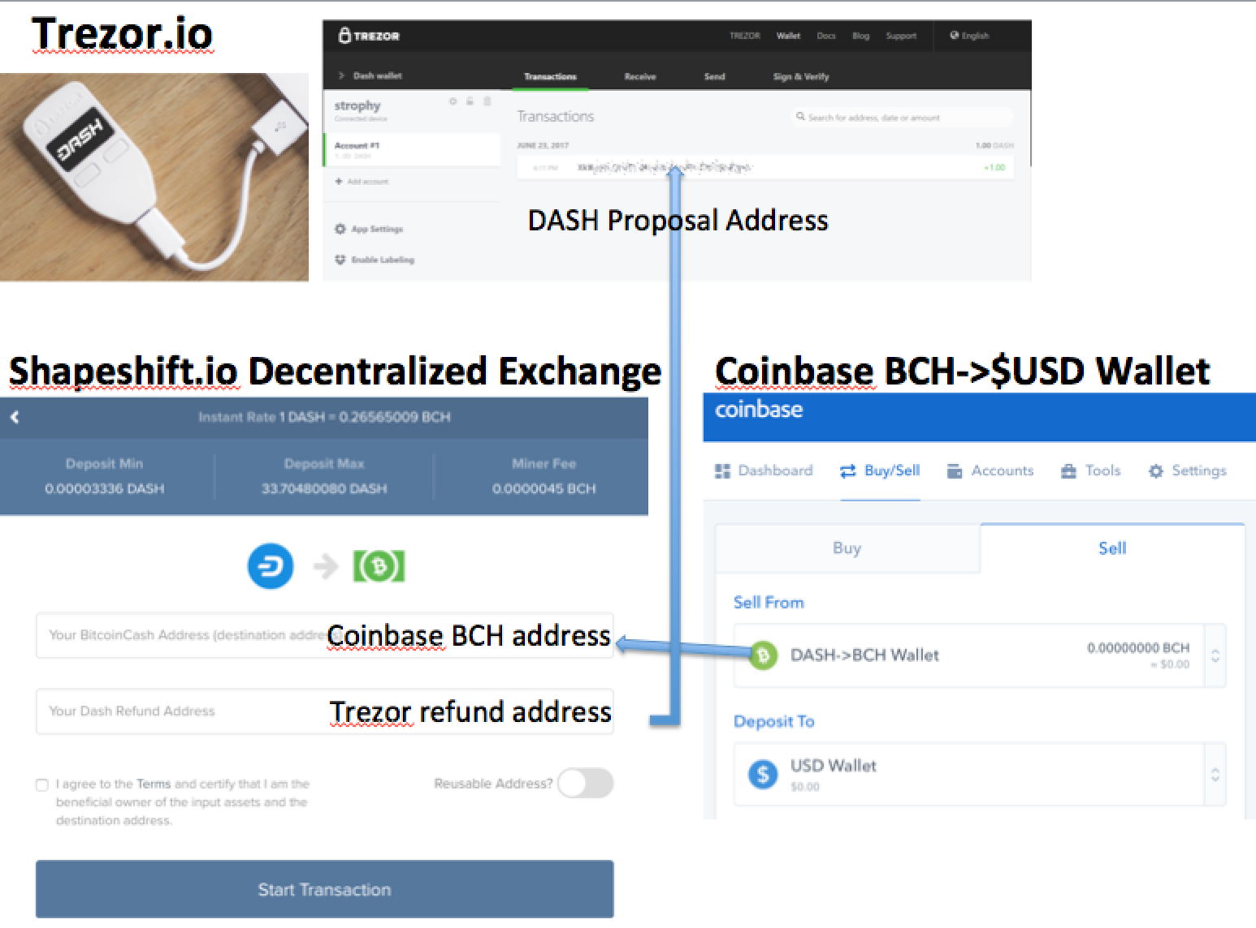
Figure 1. Schematic for Dash award distribution. Dash was first received on a Trezor.io cold wallet (top). Dash was converted into a Coinbase compliant currency (Bitcoin = BTC, Litecoin = LTC, Bitcoin Cash = BCH, Ether = ETH) with Shapeshift.io (left). Coinbase.com converted Bitcoin Cash into USD (right). Blockchains provide financial clarity of every transaction on public ledgers leaving far stronger audit trail for research spending patterns.

The cryptocurrency exchange Shapeshift.io was utilized to exchange Dash into Bitcoin cash (BCH) for final conversion into US dollars (USD) at Coinbase.com (Figure 1.). Careful attention to different Bitcoin cash address formats is required for Shapeshift.io integration with Coinbase.com. Once a transaction is six blocks deep into the blockchain (~60 minutes), Coinbase.com enables sale of crypto to USD and transfer to your connected bank via Automated Clearing House (ACH) in 3-4 days. Transactions from Dash to Coinbase.com took under 2 hours to be 6 block confirmed at Coinbase.com .The Dash to BCH transaction was required since Coinbase did not accept Dash in early 2018. All currency swaps were performed on the business day (or the following the day for weekend distributions) of Dash superblock issuance to avoid currency volatility. Due to transaction fees and ACH delays, it is preferable to pay vendors directly with Dash where accepted.

Genomic methods
The initial budget for the sequencing project was $71K and can be seen on the public project proposal (https://www.dashcentral.org/p/MedicinalGenomics_II#comments). Throughout this project the Dash currency decayed from $475/Dash to $130/Dash putting increased strain on the project goals. The project initially planned to utilize multiple sequencing technologies from Illumina, Dovetail Genomics, Oxford Nanopore, and Pacific Biosciences all in parallel. As the currency declined we opted to take a more serial approach and prioritized shotgun sequencing efforts on the Pacific Biosciences Sequel® platform and Phase Genomics HiC Promixo® methods. Given Pacific Biosciences long reads and random error profile, we believed this platform would provide the best glimpse of a 66.5% AT rich genome with high polymorphism rate.

Candidate plant genomes were screened for heterozygosity, sex and Type II status (Bt:Bd allele or CBDA & THCA producing). Screening for heterozygosity was performed with Illumina MiSeq® and Sure Select® libraries targeting 3.2Mb of the Cannabis genome. This sequencing covered THCA synthase (THCAS) and CBDA synthase (CBDAS) and was utilized to confirm youPCR™ screening for Type II plants. Mutations in THCAS and CBDAS can predict the Bt:Bd allele³⁹. These QCs were performed on the genomic DNA prior to proceeding with the generation of 91X whole genome shotgun coverage.

High molecular weight DNA was extracted from isopropanol treated stalk and leaf, utilizing a modified CTAB, Chloroform and SPRI technique. A daily lab journal was recorded at https://www.medicinalgenomics.com/crypto-funded-public-genomics/
Various important experimental data was hashed and blockchain notarized using Stampd.io.

Bioinformatic methods
SMRTbell® sequencing libraries were constructed by the service provider according to the manufacturers instructions and produced 91Gb of raw sequence data with a read length N50 of 32Kb. These were assembled into 665kb N50 contigs with the FALCON Unzip assembler v.0.3.0. Arrow was used to polish the assembly⁴⁰. Quast was used to calculate assembly statistics. BUSCO was utilized to measure a 93.6% complete ortholog assembly. SALSA was utilized to process the HiC data⁴⁵. CLC Bio workbench v9.0.1 was used to visualize the improvement in Illumina read mapping with the uncollapsed FALCON assembly and build Synthase cladograms. Earlier Illumina exclusive genome assemblies collapsed many repeats into a much smaller genome creating many read mapping artifacts. These compressed references produce elevated read mapping quality scores as the mapping algorithm falsely assumes there is only one placement for repetitive reads.

BLAST analysis was performed to look for THCA synthase (THCAS), CBCA synthase and CBDA synthase (CBDAS). Prior to this assembly these genes were always on different small contigs or not existent. The Pacific Bioscience assembly not only assembled these genes in tandem repeats but also highlighted many other copies of mutated synthase genes clustered around each synthase gene. This copy number expansion has been explored before but never resolved into contiguous tandem repeats.

Assembly fasta files were placed on to IPFS.io. The interplanetary file system (IPFS) is a distributed drive storage system that performs much like bit torrent. Documents can be retrieved using IPFS get <hash of file>. Assemblies were also placed on Mega.nz, AWS and NCBI. The Hashes of the assemblies were spent into a Dash OP_RETURN. Due to the large genome size a command line API for Stampd.io was utilized.

Results
All previous Cannabis assemblies were evaluated with Quast.v4.6.3. The Pacific Biosciences Jamaican Lion Dash assembly has N50 contig lengths 300x larger than the 2011 Illumina generated references. The genome size is 2-5 X larger than previous genome estimates (Table 1). While the genome remains 66% AT, the previously reported 1% polymorphism rate is likely overestimated as a result of collapsed preliminary Illumina assemblies. Hi-C data may resolve haplotigs that could be inflating the current PacBio assembly size.
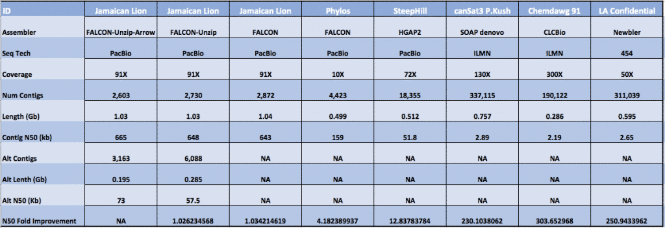
Table 1: All public Cannabis assemblies to date. Quast v4.6.3 was utilized to measure the assembly statistics. Ns were removed from references before calculations.
Data Access and Notarization
CIBR review
https://www.medicinalgenomics.com/cryptocurrency-incentivized-blockchain-recorded-peer-review-cibr/

DASH blockchain records
filename: jamaicanlion_falcon_unzip_arrow_haplotigs_160818.fasta.gz,
digest:db9216e4e1e1b72b1540ab7d9ae76462ebaaed5710e32e39363bfc9587bc73c0,
transaction id:73012ba6ef8b9af67a6b9e36974bd38c37c9c1d6e6ecab873e657b79f1da17fa

filename: jamaicanlion_falcon_unzip_arrow_primary_160818.fasta.gz,
digest:21440180f4e06755c701fdc3f863d9d3edf5fdbea721ca122bce84ee672061dd,
transaction id:0653c54153493f2b8d6c1cee66c869454c3ff904aa18ed18f92f608ad7383a77

IPFS.io Hashes
ipfs add jamaicanlion_falcon_unzip_arrow_primary_160818.fasta
added QmWKQeaKqxREq8yuMeJTh7ZeXc9Kmn2PQnc1MuwrscjJ6V
ipfs add jamaicanlion_falcon_unzip_arrow_haplotigs_160818.fasta
added QmebrttnJtKUC5NUYJMpEcApukvx2zC2142CypQXy8D8zo

Mega.nz
https://mega.nz/#!JMYlBapT!Ygq4bJruNAjB0GBUUvhVOdw8sT2ee2LgFQeJ9eDvVa0
https://mega.nz/#!BZI2AQKB!l6wiPCYaagkLiGrnG4x87Vzl1cYi6shrJfXPXfrsRW8
Salsa HiC output
https://mega.nz/#!5dgTWSDT!1iAQK595oc-ZNsFbUWFqSPnIOeeyMkw3e_2Hlu_-4x0
https://mega.nz/#!YR5ERI7I!0MNVhQc-mRjonjZiLI5P6hwVDL43VvPatUE9eBBGh8Q
Raw HiC reads
https://mega.nz/#!1U4RHQ6Z!rTceqTNYQdSJJTN7qfIJ5uKVSmecfM3GMI4qCwfLlpk
https://mega.nz/#!gAgSlKDa!tzyn2cdokHU9GQlv_i_4DVpDRid8Zhq_niEFgNKzj18
Raw PacBio subreads
https://mega.nz/#F!4JogyYSa!24HWGDfM4y9AvGtvhASB4A

AWS
http://mgcdata.s3.amazonaws.com/reference/jamaicanlion_falcon_unzip_arrow_primary_160818.fasta.gz
http://mgcdata.s3.amazonaws.com/reference/jamaicanlion_falcon_unzip_arrow_haplotigs_160818.fasta.gz

NCBI

https://submit.ncbi.nlm.nih.gov/api/2.0/files/g9c4akug/jamaican_lion_dash_arrow_primary.fsa/?format=attachment

https://www.ncbi.nlm.nih.gov/bioproject/?term=Jamaican%20Lion
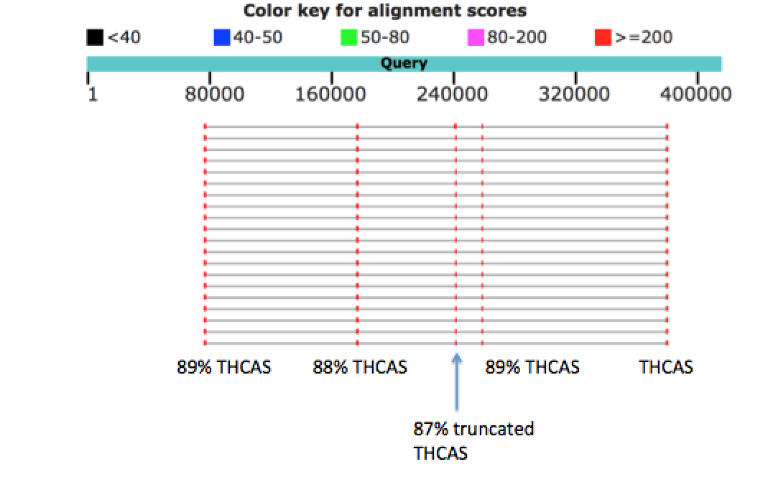

THCA Synthase, CBCA Synthase and CBDA Synthase
THCAS and CBDAS genes have been previously reported to be in linkage by Weiblen et al. The FALCON unzipped assembly shows these two genes to be on separate contigs but with signs of tandem repeat structures. Contig 000410 demonstrates 3-4 tandem copies of CBCA synthase. BLAST of the 000692 contig to NCBI demonstrates multiple partial copies of THCA synthase (Figure 2). It is unclear if these copies make productive enzymes, fold esoteric cannabinoid precursors or are involved in homologous recombination. This Type II plant synthesizes a 2:1 ratio of CBDA:THCA. From this chemotype, one might expect 2 functional copies of CBDAS and one functional copy of THCAS. Further work is required to understand the roll of the other copies of THCAS sequence in the genome. While these copies of THCAS are heavily mutated, it may be premature to assume they are pseudogenes given many have complete open reading frames. The THCA-like alleles require further phasing, cloning and expression to fully characterize their precise contribution to chemotype. At least one of the copies of THCAS sequence is identical to a THCAS dominant type I cannabis plant known as Skunk (accession # KJ469378.1, AB057805.1) and presumed to be fully functional with CBGA precursor. There is an additional fully function CBDA synthase gene sequence on contig 001055. Four tandem copies of CBCA synthase can be found on contig 000410. A 4.5Mb scaffold (scaffold_347) contains 14 putative synthase genes with over 90% nucleotide sequence homology to THCAS. In total, 30 cannabinoid synthase-like sequences are are arrayed in 5 scaffolds (Supplemental table 1).
Figure 2A: BLAST of contig 000692 to NCBI displays tandem THCAS sequences.

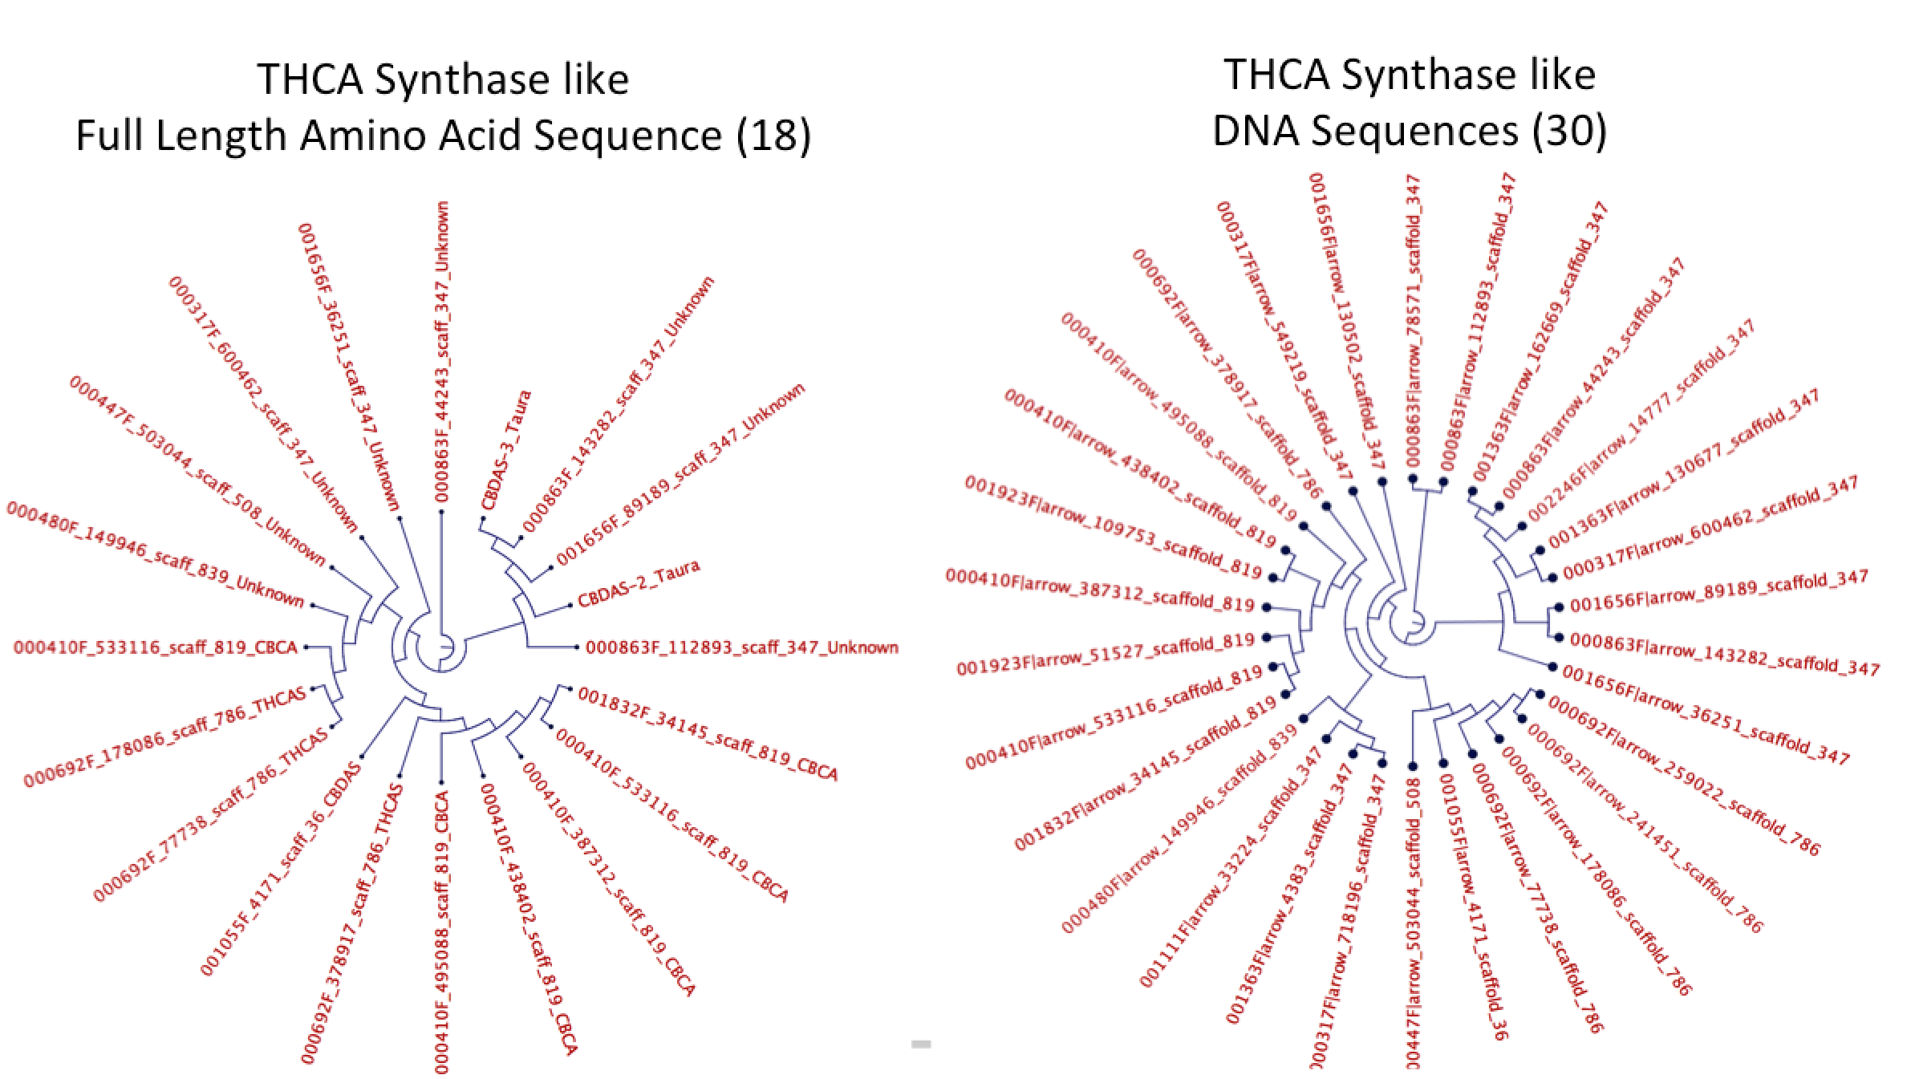
Figure 2B: Cladogram of THCA-like sequences. Full Length amino acid alignment of Synthase like sequences (left). DNA Sequence Alignments of Synthase like sequences (right). Nomenclature = Contig#_location_scaffold#_GeneName.

Etienne de Meijer et al. detailed the inheritance of chemical phenotypes in Cannabis.

Here Type II plants are described as plants that make both THCA and CBDA. Independent assortment of diploid alleles suggests there can be 1:2 and 2:1 functional gene dosages for CBDAS:THCAS in a diploid plant. Further work is required to correlate such allele distributions with measured chemotypes in the plant. This simplified “diploid” model may be further complicated by tandem duplications of synthase genes.

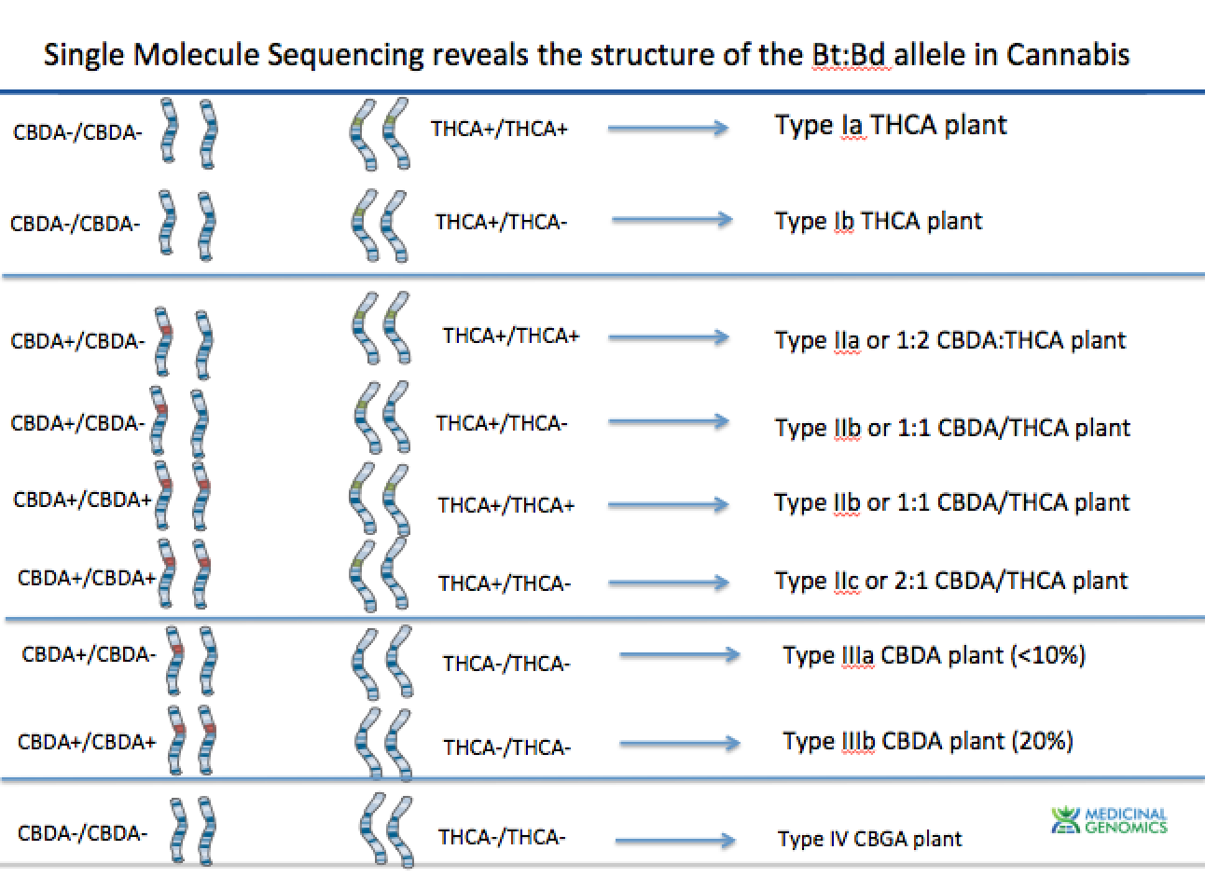
Figure 2C: Simplified independent assortment of CBDAS and THCAS genetics.

Improvements to short read mapping

Assemblies constructed with long reads resolve repeats and tandem duplication events that confuse shorter read assemblies. Once the longer read genome assemblies are constructed, short read tools like Illumina can be improved through more precise and productive read mapping (Figure 3). Figure 4 demonstrates some of these read mapping artifacts with previous collapsed assemblies. Short reads are often mis-mapped and as a result higher polymorphism rates are observed with the reads. This complicates phasing and interpretation of amino acid sequences and the impact of mutations on gene expression.

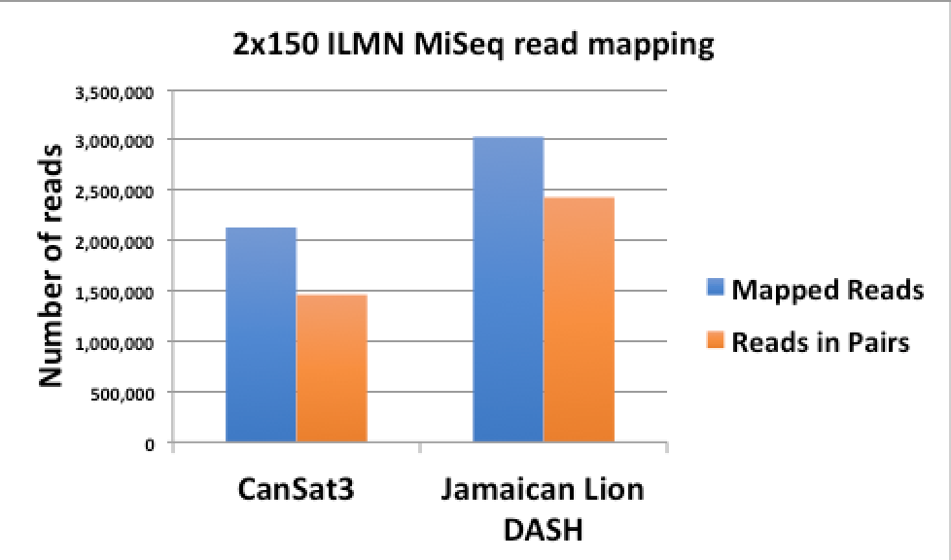
Figure 3: CLC Bio Read Mapping of the same dataset to 2011 references CanSat3 to the Jamaican Lion DASH reference genome. A higher % of reads map and a higher percentage of reads map as paired end reads.

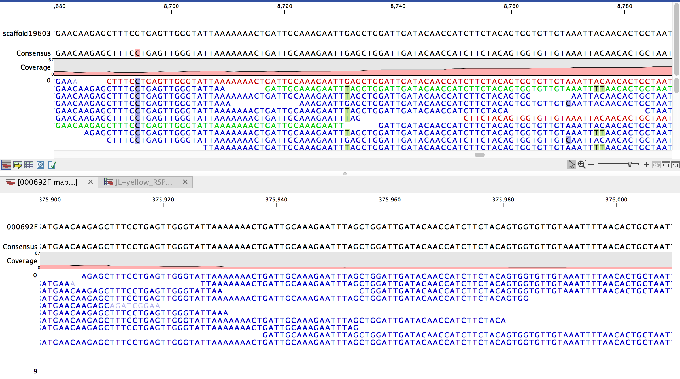
Figure 4: Illumina MiSeq reads from Jamaican Lion mapped (CLCbio V9.0.1) back to CanSat3 reference from 2011 (Top) and the Jamaican Lion reference (Bottom). Red and Green reads are reads that map as only forward and reverse reads (not paired). Blue reads are paired reads. 4 false positive SNPs/100bp are generated with the old reference. Even paired reads are mismapped presumably due to the other pseudogene copies of THCA synthase not being in the CanSat3 assembly.

Conclusions
Cryptocurrency funded science offers a novel and apolitical method to solve challenging scientific problems in short time frames. A refined Cannabis genome assembly can aid in better marker assisted selection and QTL maps. Breeders rights and intellectual property can also be addressed with genomic blockchains like Kannapedia.net. This sequence forms the basis for a forensic level, blockchain secured seed to sale tracking system that can ensure patients high fidelity with the highly variable cannabis expression seen in the marketplace today. While cryptocurrencies are often slandered for nefarious use, publically sequencing the genome of a plant with an impressive medicinal pharmacopeia represents a use case that challenges these stereotypes.

Author Contributions
KJM-Designed study, grant application, field DNA isolation, cultivation advise, data analysis, cryptocurrency methods, manuscript writing
YH- DNA purification, Library construction, DNA sequencing
LTK- DNA purification, Library construction, DNA sequencing
HE- DNA purification
LZ- Library construction, DNA sequencing
BL- Data analysis and Genome completeness
ZE- Cultivation advisor
LS- HMW DNA purification and QC, DNA sequencing
ED- HMW DNA purification and QC, DNA Sequencing
WB- DNA shotgun and assembly advisor
TH- DNA shotgun and assembly advisor

Acknowledgments
R.T.M for his brave fight with cancer and advice on this matter.
Rebecca McKernan for editorial advice.
Kyle Boyar for grant review.
Ganjahnetics for breeding the original Jamaican Lion seeds in 2007.
Solarguy, Mastermined, Mark Mason, Joel Valenzuela, TanteStefana, Coingun and the Dash masternode network for their advice and guidance on the Dash proposal process.

1. Cotter. Gutenberg's Legacy: Copyright, Censorship, and Religious Pluralism. California Law Review. 2003;91(2).
2. Mengistu. The Evolutionary Origins of Hierarchy. PLoS computational biology. 2016;12(6).
3. Kramer AD, Guillory JE, Hancock JT. Experimental evidence of massive-scale emotional contagion through social networks. Proceedings of the National Academy of Sciences of the United States of America. 2014 Jun 17;111(24):8788-90. PubMed PMID: 24889601. Pubmed Central PMCID: 4066473.
4. Coviello L, Sohn Y, Kramer AD, Marlow C, Franceschetti M, Christakis NA, et al. Detecting emotional contagion in massive social networks. PloS one. 2014;9(3):e90315. PubMed PMID: 24621792. Pubmed Central PMCID: 3951248.
5. Gilder. Life after Google: The fall of big data and the rise of the blockchain economy. 2018.
6. Stigler. The Theory of Economic Regulation. The Bell Journal of Economics and Management Science. 1971.
7. Korlach J, Marks PJ, Cicero RL, Gray JJ, Murphy DL, Roitman DB, et al. Selective aluminum passivation for targeted immobilization of single DNA polymerase molecules in zero-mode waveguide nanostructures. Proceedings of the National Academy of Sciences of the United States of America. 2008 Jan 29;105(4):1176-81. PubMed PMID: 18216253. Pubmed Central PMCID: 2234111.
8. Nakamoto. Bitcoin: a peer-to-peer electronic cash system. https:// bitcoinorg/bitcoinpdf. 2008.
9. Antonopoulos AM, Tapscott D. The internet of money : a collection of talks. xviii, 132 p.
10. Shin. Is This Massive Power Struggle About To Blow Up Bitcoin? Forbes. 2017;March 21.
11. Duffield. Dash: A Privacy-Centric Crypto-Currency. GitHub. 2014;https://github.com/dashpay/dash/wiki/Whitepaper.
12. David. Ouroboros Praos: An adaptively-secure, semi-synchronous proof-of-stake blockchain. IACR. 2017.
13. Shaughnessy. Solving the $190 billion Annual Fraud Problem: More on Jumio. Forbes. 2011 03/24/11.
14. Gencer. Decentralization in Bitcoin and Ethereum Networks. Arxivorg. 2018 (Mar 29 2018).
15. Baird. Hedera: A governing council & public Hashgraph network. https://s3amazonawscom/hedera-hashgraph/hh-whitepaper-v11-180518pdf. 2018.
16. Rocket T. Snowflake to Avalanche: A Novel Metastable Consensus Protocol Family for Cryptocurrencies.https://ipfs.io/ipfs/QmUy4jh5mGNZvLkjies1RWM4YuvJh5o2FYopNPVYwrRVGV.
17. Von Mises L. The theory of money and credit. Indianapolis: Liberty Classics; 1980. 541 p. p.
18. Olson. Chart of the Week: Average Purchase Amount at Dispensaries Ranges From $60 to $100+. Marijuana Business Daily. 2015;https://mjbizdaily.com/chart-week-average-marijuana-dispensary-purchase-amounts-range-60-100/.
19. Gilen. Testing Theories of American Politics: Elites, Interest Groups, and Average Citizens. American Political Science Association. 2014.
20. Bradford. Association between us state medical cannabis laws and opioid prescribing in the medicare part d population. JAMA. 2018 05/01/2018;178(5).
21. Perucca E. Cannabinoids in the Treatment of Epilepsy: Hard Evidence at Last? Journal of epilepsy research. 2017 Dec;7(2):61-76. PubMed PMID: 29344464. Pubmed Central PMCID: 5767492.
22. Pascual D, Sanchez-Robles EM, Garcia MM, Goicoechea C. Chronic pain and cannabinoids. Great expectations or a christmas carol. Biochemical pharmacology. 2018 Jul 27. PubMed PMID: 30056139.
23. Maurya N, Velmurugan BK. Therapeutic applications of cannabinoids. Chemico-biological interactions. 2018 Jul 21;293:77-88. PubMed PMID: 30040916.
24. Hinz B, Ramer R. Anti-tumour actions of cannabinoids. British journal of pharmacology. 2018 Jul 17. PubMed PMID: 30019449.
25. Huskey A. Cannabinoids in cancer pain management. Journal of pain & palliative care pharmacotherapy. 2006;20(3):43-6. PubMed PMID: 16931481.
26. Izzo AA, Camilleri M. Cannabinoids in intestinal inflammation and cancer. Pharmacological research. 2009 Aug;60(2):117-25. PubMed PMID: 19442536.
27. Kogan NM. Cannabinoids and cancer. Mini reviews in medicinal chemistry. 2005 Oct;5(10):941-52. PubMed PMID: 16250836.
28. Ladin DA, Soliman E, Griffin L, Van Dross R. Preclinical and Clinical Assessment of Cannabinoids as Anti-Cancer Agents. Frontiers in pharmacology. 2016;7:361. PubMed PMID: 27774065. Pubmed Central PMCID: 5054289.
29. Ligresti A, Moriello AS, Starowicz K, Matias I, Pisanti S, De Petrocellis L, et al. Antitumor activity of plant cannabinoids with emphasis on the effect of cannabidiol on human breast carcinoma. The Journal of pharmacology and experimental therapeutics. 2006 Sep;318(3):1375-87. PubMed PMID: 16728591.
30. Mackie K, Hille B. Cannabinoids inhibit N-type calcium channels in neuroblastoma-glioma cells. Proceedings of the National Academy of Sciences of the United States of America. 1992 May 1;89(9):3825-9. PubMed PMID: 1315042. Pubmed Central PMCID: 525583.
31. Martin BR, Wiley JL. Mechanism of action of cannabinoids: how it may lead to treatment of cachexia, emesis, and pain. The journal of supportive oncology. 2004 Jul-Aug;2(4):305-14; discussion 14-6. PubMed PMID: 15357514.
32. Massi P, Valenti M, Solinas M, Parolaro D. Molecular mechanisms involved in the antitumor activity of cannabinoids on gliomas: role for oxidative stress. Cancers. 2010 May 26;2(2):1013-26. PubMed PMID: 24281104. Pubmed Central PMCID: 3835116.
33. McAllister SD, Chan C, Taft RJ, Luu T, Abood ME, Moore DH, et al. Cannabinoids selectively inhibit proliferation and induce death of cultured human glioblastoma multiforme cells. Journal of neuro-oncology. 2005 Aug;74(1):31-40. PubMed PMID: 16078104.
34. McAllister SD, Soroceanu L, Desprez PY. The Antitumor Activity of Plant-Derived Non-Psychoactive Cannabinoids. Journal of neuroimmune pharmacology : the official journal of the Society on NeuroImmune Pharmacology. 2015 Jun;10(2):255-67. PubMed PMID: 25916739. Pubmed Central PMCID: 4470774.
35. McCarberg BH. Cannabinoids:their role in pain and palliation. Journal of pain & palliative care pharmacotherapy. 2007;21(3):19-28. PubMed PMID: 18032352.
36. Mechoulam R, Hanu L. The cannabinoids: an overview. Therapeutic implications in vomiting and nausea after cancer chemotherapy, in appetite promotion, in multiple sclerosis and in neuroprotection. Pain research & management. 2001 Summer;6(2):67-73. PubMed PMID: 11854768.
37. Demirgüç-Kunt A, World Bank. The Global Findex database 2017 : measuring financial inclusion and the fintech revolution. xv, 131 pages p.
38. Lander ES, Linton LM, Birren B, Nusbaum C, Zody MC, Baldwin J, et al. Initial sequencing and analysis of the human genome. Nature. 2001 Feb 15;409(6822):860-921. PubMed PMID: 11237011.
39. Staginnus C, Zorntlein S, de Meijer E. A PCR marker linked to a THCA synthase polymorphism is a reliable tool to discriminate potentially THC-rich plants of Cannabis sativa L. Journal of forensic sciences. 2014 Jul;59(4):919-26. PubMed PMID: 24579739.
40. Chin CS, Peluso P, Sedlazeck FJ, Nattestad M, Concepcion GT, Clum A, et al. Phased diploid genome assembly with single-molecule real-time sequencing. Nature methods. 2016 Dec;13(12):1050-4. PubMed PMID: 27749838. Pubmed Central PMCID: 5503144.
41. Mikheenko A, Prjibelski A, Saveliev V, Antipov D, Gurevich A. Versatile genome assembly evaluation with QUAST-LG. Bioinformatics. 2018 Jul 1;34(13):i142-i50. PubMed PMID: 29949969. Pubmed Central PMCID: 6022658.
42. Gurevich A, Saveliev V, Vyahhi N, Tesler G. QUAST: quality assessment tool for genome assemblies. Bioinformatics. 2013 Apr 15;29(8):1072-5. PubMed PMID: 23422339. Pubmed Central PMCID: 3624806.
43. Waterhouse RM, Seppey M, Simao FA, Manni M, Ioannidis P, Klioutchnikov G, et al. BUSCO applications from quality assessments to gene prediction and phylogenomics. Molecular biology and evolution. 2017 Dec 6. PubMed PMID: 29220515. Pubmed Central PMCID: 5850278.
44. Simao FA, Waterhouse RM, Ioannidis P, Kriventseva EV, Zdobnov EM. BUSCO: assessing genome assembly and annotation completeness with single-copy orthologs. Bioinformatics. 2015 Oct 1;31(19):3210-2. PubMed PMID: 26059717.
45. Ghurye J, Pop M, Koren S, Bickhart D, Chin CS. Scaffolding of long read assemblies using long range contact information. BMC genomics. 2017 Jul 12;18(1):527. PubMed PMID: 28701198. Pubmed Central PMCID: 5508778.
46. Altschul SF, Koonin EV. Iterated profile searches with PSI-BLAST--a tool for discovery in protein databases. Trends in biochemical sciences. 1998 Nov;23(11):444-7. PubMed PMID: 9852764.
47. Altschul SF, Madden TL, Schaffer AA, Zhang J, Zhang Z, Miller W, et al. Gapped BLAST and PSI-BLAST: a new generation of protein database search programs. Nucleic acids research. 1997 Sep 1;25(17):3389-402. PubMed PMID: 9254694. Pubmed Central PMCID: 146917.
48. Weiblen GD, Wenger JP, Craft KJ, ElSohly MA, Mehmedic Z, Treiber EL, et al. Gene duplication and divergence affecting drug content in Cannabis sativa. The New phytologist. 2015 Dec;208(4):1241-50. PubMed PMID: 26189495.
49. McKernan K. Single molecule sequencing of THCA synthase reveals copy number variation in modern drug-type Cannabis sativa L. BioRXIV. 2015.

